AI POWERED CROP DISEASE DETECTION AND RECOMMENDATION SYSTEM FOR SUSTAINABLE DEVELOPMENT
Block Diagrams (all)
Department of Computer Science and Engineering, [COLLEGE NAME]
Batch C16 (CSE-C) · Academic year [ACADEMIC YEAR]
Table 1: Project team
S.No. | Student name | Roll number
1 | Pishke Vishal | 23K91A05J2
2 | Kyatham Nithisha | 23K91A05D1
3 | Mekala Tharun Kuruma | 23K91A05F1
4 | Nakka Sreenith | 23K91A05H0

Project guide: V Krishna Teja
Chapter and section numbers quoted in the text (for example Chapter 8 or Section 6.2) refer to the full project report, 17.Final Document. Figures and tables in this document are numbered from 1.

1. INDEX OF DIAGRAMS
Every diagram was generated from the real design by scripts/docs_build/make_diagrams.py (matplotlib, 150 dpi) and mirrors the code in backend/main.py and agrivision/. The application has no ORM classes, so the UML diagram shows modules and the two table-backed entities, and the entity-relationship diagram shows the two SQLite tables.
Table 2: Diagrams in this document
No. | Diagram | Image file
1 | System architecture | docs/diagrams/01_system_architecture.png
2 | High-level workflow | docs/diagrams/02_high_level_workflow.png
3 | DFD level 0 (context diagram) | docs/diagrams/03_dfd_level0.png
4 | DFD level 1 | docs/diagrams/04_dfd_level1.png
5 | DFD level 2 (process 3.0) | docs/diagrams/05_dfd_level2.png
6 | UML class diagram | docs/diagrams/06_uml_class_diagram.png
7 | Sequence diagram of the main flow | docs/diagrams/07_sequence_diagram.png
8 | Use case diagram | docs/diagrams/08_use_case_diagram.png
9 | Entity-relationship diagram | docs/diagrams/09_er_diagram.png
10 | Flowchart of the core algorithm | docs/diagrams/10_core_algorithm_flowchart.png
11 | Experiment protocol | docs/diagrams/11_experiment_protocol.png
12 | Deployment view | docs/diagrams/12_deployment.png

2. DIAGRAMS

System architecture
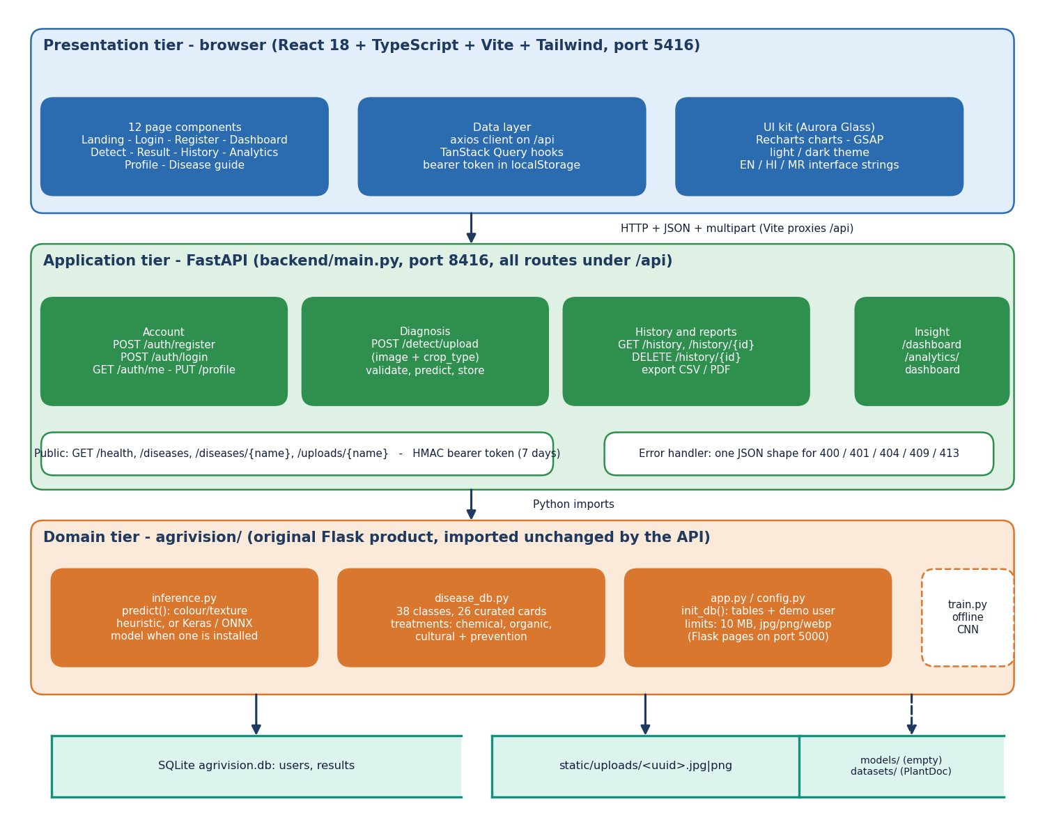
Figure 1: Three-tier architecture of AgriVision: browser, FastAPI service, original Flask modules, and the data stores.
The browser tier is a React single-page application (twelve page components, axios client, TanStack Query hooks, English, Hindi and Marathi interface strings) served by Vite on port 5416, which proxies every /api request to the application tier. The application tier is backend/main.py: sixteen FastAPI routes grouped into account, diagnosis, history and reports, and insight (dashboard and analytics), plus public routes for health, the disease guide and uploaded images. The domain tier is the unchanged Flask product in agrivision/: inference.py (the diagnosis engine), disease_db.py (the 38-class knowledge base) and app.py/config.py (table creation, limits). Below them sit the SQLite file with the users and results tables, the folder of uploaded images, and the offline models/ and datasets/ folders. The models/ folder is empty in the shipped product.

High-level workflow
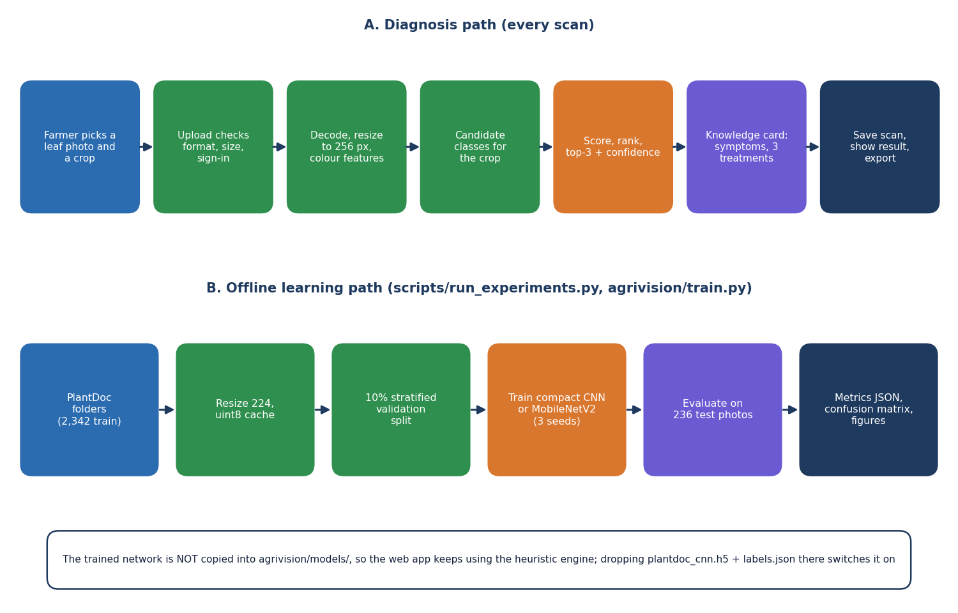
Figure 2: High-level workflow: the diagnosis path used on every scan, and the offline learning path used to measure accuracy.
The upper row is what happens when a farmer scans a leaf: the photograph and crop are uploaded, the service checks the sign-in, the file extension, size and emptiness, the engine decodes and resizes the image to 256 pixels and measures colour and texture shares, the candidate classes of the chosen crop are selected, the classes are scored and ranked, the top three are returned with a confidence, the knowledge card of the top class supplies symptoms and three treatments, and the scan is stored and shown. The lower row is the offline path that produced the accuracy figures in this report: PlantDoc folders are resized to 224 pixels, a stratified 10 % validation split is taken, models are trained with three seeds and evaluated on the 236 test photographs. The trained network is not copied into the application.

DFD level 0 (context diagram)
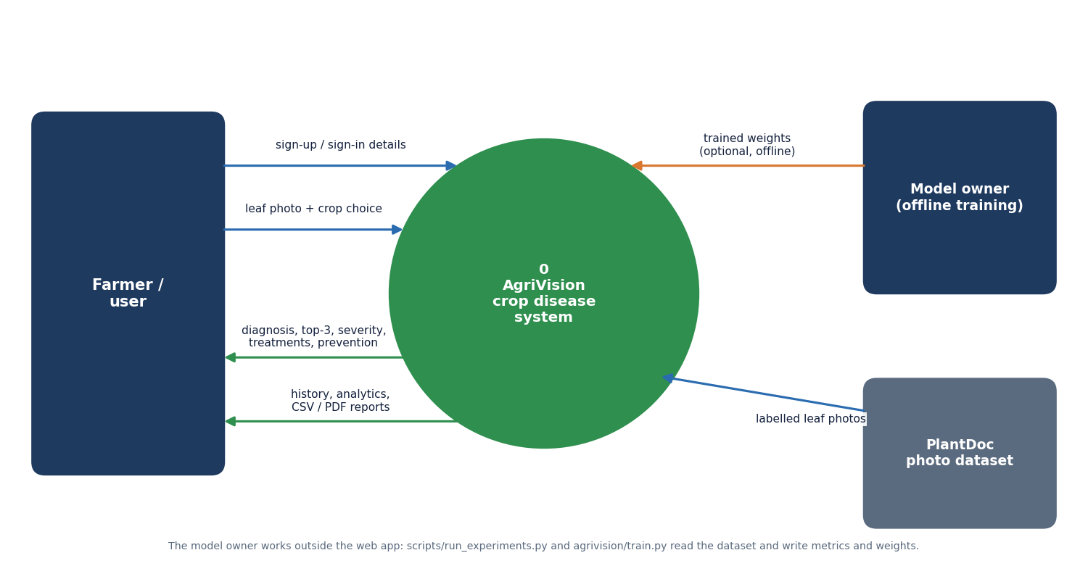
Figure 3: Context diagram (DFD level 0) of AgriVision.
The whole system is one process, 0 AgriVision. The farmer sends sign-up and sign-in details and a leaf photograph with a crop choice, and receives the diagnosis with the top three predictions, severity, treatments and prevention advice, and the history, analytics and exported CSV or PDF reports. The model owner and the PlantDoc dataset are drawn as external entities because they work outside the web application: the dataset supplies labelled leaf photographs to the training and measurement scripts, and the model owner may return trained weights that inference.py would load if they were placed in agrivision/models/.

DFD level 1
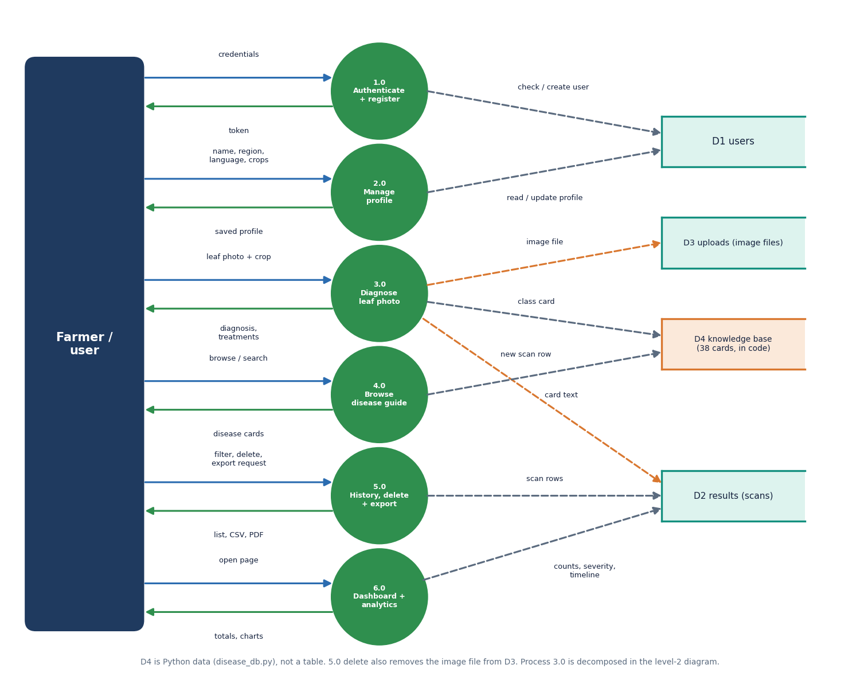
Figure 4: DFD level 1: six processes and four data stores.
Level 1 splits the system into six processes: 1.0 Authenticate and register (reads and writes D1 users and returns a token), 2.0 Manage profile (language, region, crops), 3.0 Diagnose leaf photo (writes the image file to D3 uploads and a scan row to D2 results, reads a card from D4), 4.0 Browse the disease guide (reads D4), 5.0 History, delete and export (reads and deletes D2 rows and D3 files, produces CSV and PDF), and 6.0 Dashboard and analytics (counts and groups D2 rows). D4, the knowledge base of 38 cards, is Python data in disease_db.py and not a database table. Every process except 4.0 requires the bearer token; process 4.0 and the card lookup are public.

DFD level 2 (process 3.0)
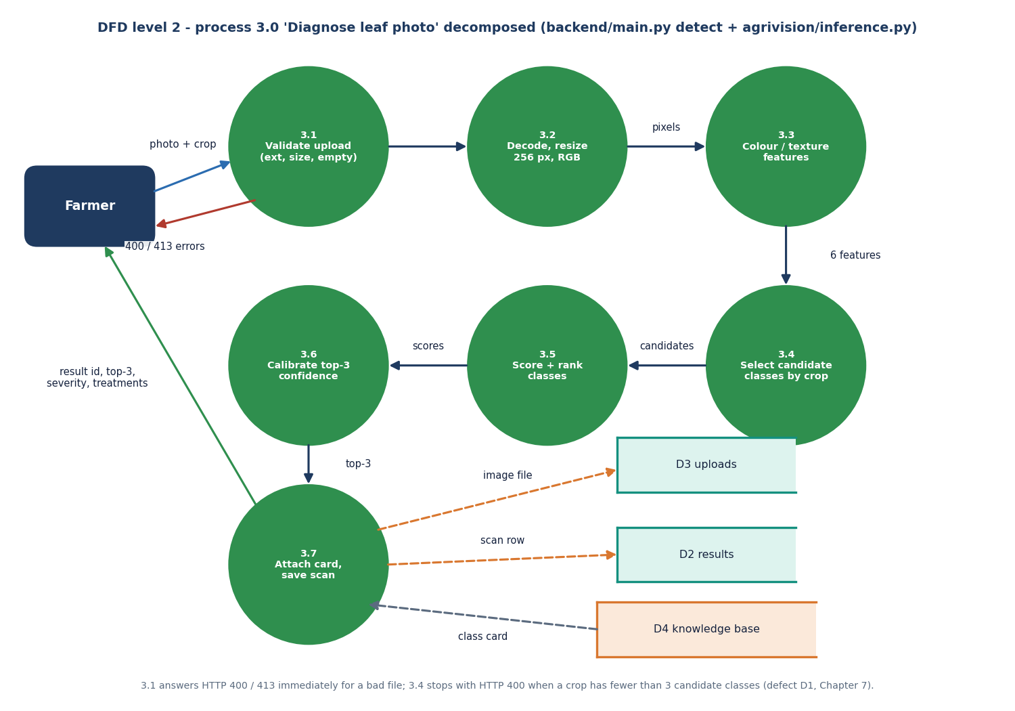
Figure 5: DFD level 2: process 3.0 'Diagnose leaf photo' decomposed into seven sub-processes.
Process 3.0 is decomposed into 3.1 Validate upload (extension, 10 MB limit, empty file), 3.2 Decode and resize to 256 x 256 RGB, 3.3 Colour and texture features (green, brown, yellow, dark and white pixel shares and the global standard deviation), 3.4 Select candidate classes by crop, 3.5 Score and rank the classes, 3.6 Calibrate the top-three confidence, and 3.7 Attach the knowledge card and save the scan. Errors leave from 3.1 (HTTP 400 or 413) and from 3.4, where a crop with fewer than three candidate classes raises an exception that the API reports as HTTP 400 (defect D1). Process 3.5 and 3.6 are replaced by a single network forward pass when a trained model file is installed.

UML class diagram
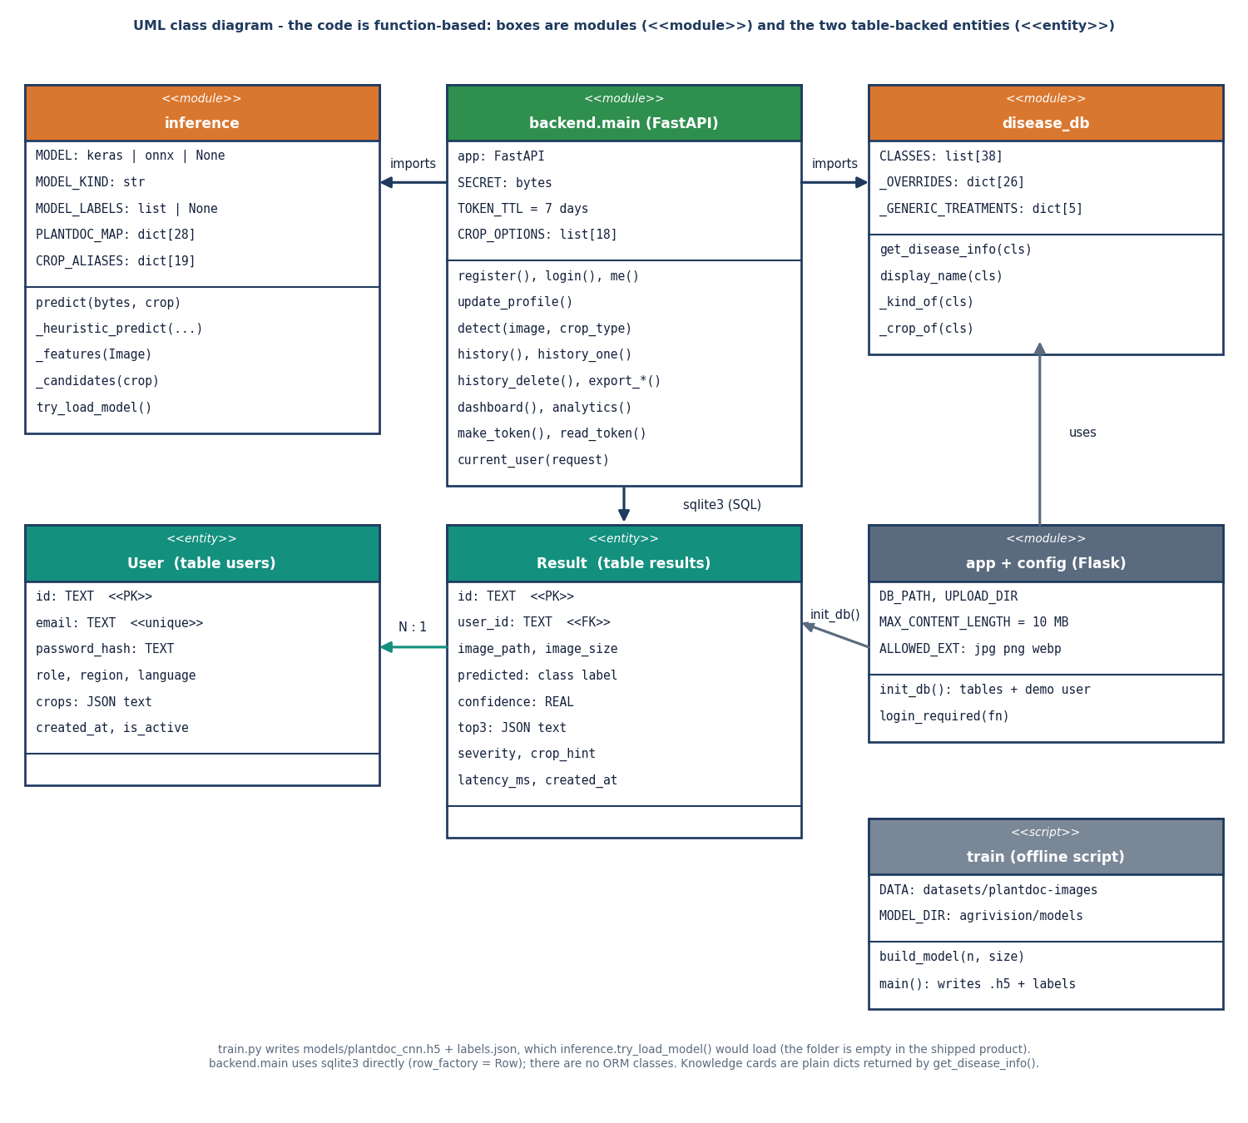
Figure 6: UML class diagram: modules of the application and the two table-backed entities.
The product is written with functions and modules rather than classes, so the diagram shows modules with the stereotype module and the two persistent entities User and Result with the stereotype entity. backend.main imports inference (the engine, with the optional model, its labels and the PlantDoc label map) and disease_db (the 38 class labels, 26 curated overrides and five generic treatment kinds). app and config hold the limits and init_db(), which creates the tables and the demo user. train is an offline script that writes the weights inference.try_load_model() would load. One User has many Results through user_id; the code reads and writes them with sqlite3 directly, without an object-relational mapper.

Sequence diagram of the main flow
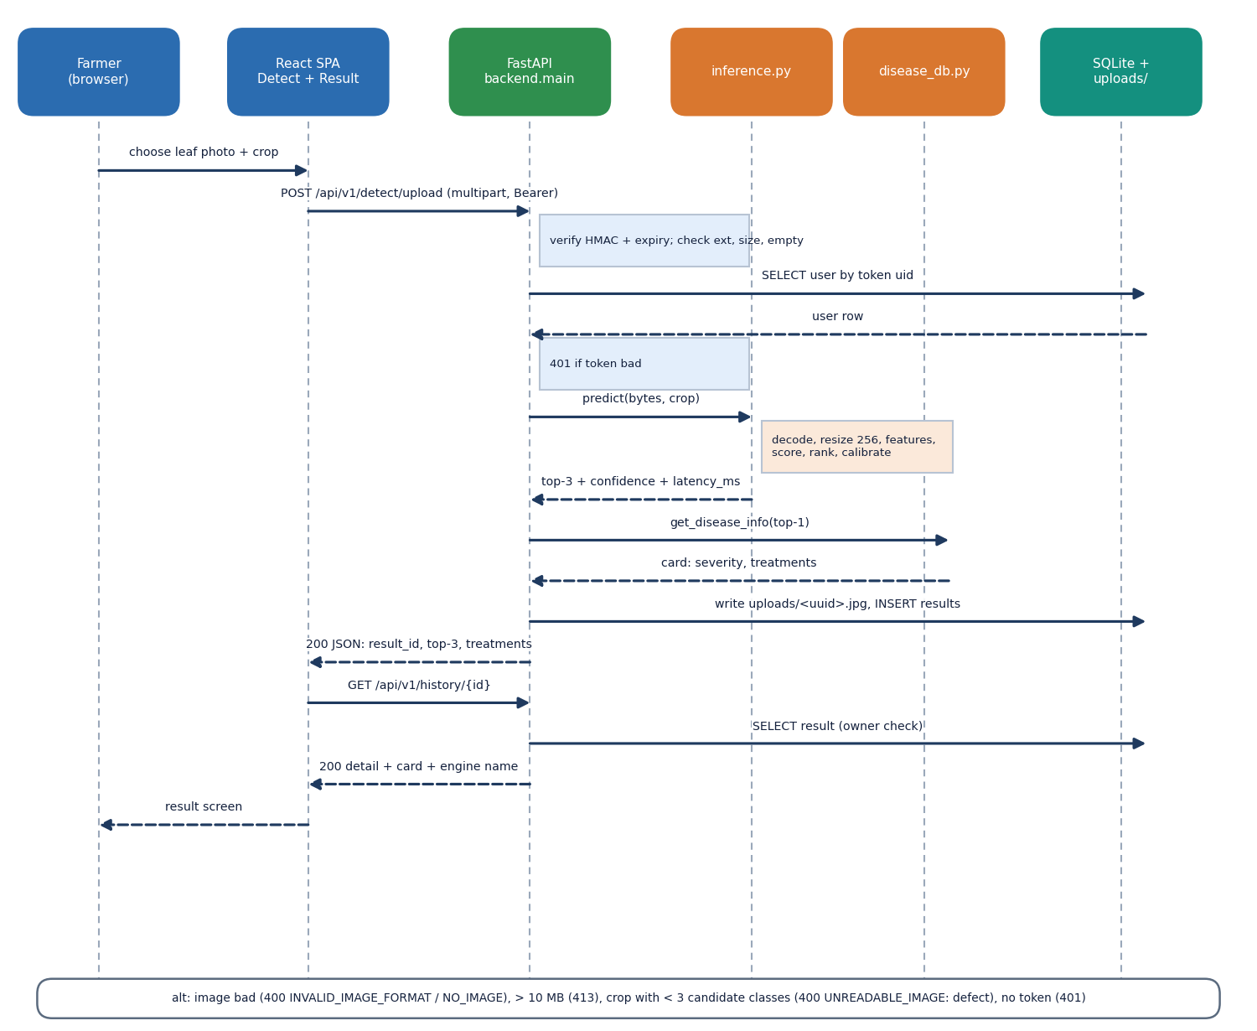
Figure 7: Sequence diagram: uploading a leaf photograph and opening the result.
The sequence follows one diagnosis. The farmer chooses a photograph and crop in the Detect page; the SPA posts the multipart form to /api/v1/detect/upload with the bearer token. The service verifies the HMAC signature and expiry, reads the user row, checks the extension, size and emptiness, and calls predict(). The engine returns the top three classes, the confidence and the latency; the service asks disease_db for the card of the top class, writes the image under a random name, inserts the result row and answers with the result id, the top three, the severity and the treatments. The SPA then requests /api/v1/history/{id}, the service checks that the scan belongs to the user, and the Result page is drawn. The bottom box lists the alternative outcomes: 400, 413 and 401.

Use case diagram
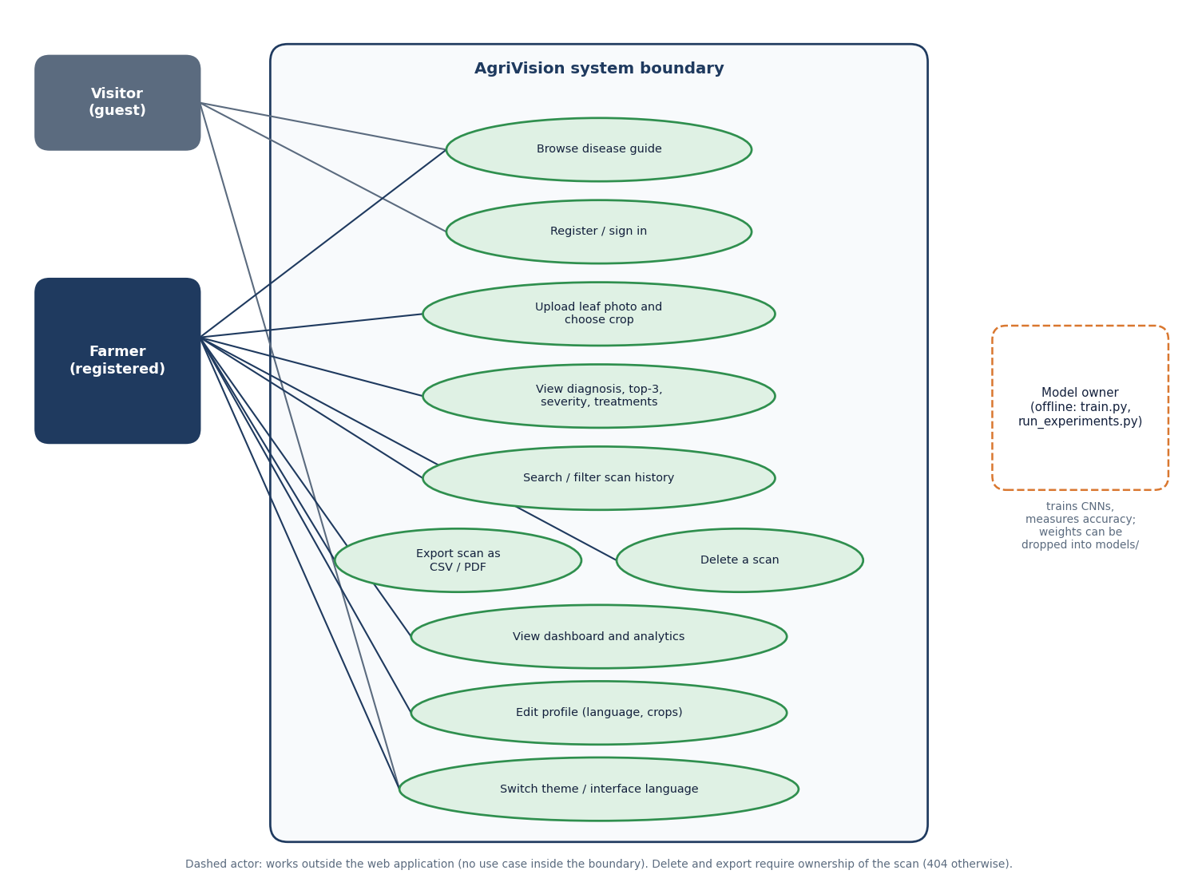
Figure 8: Use case diagram: visitor, registered farmer and the offline model owner.
A visitor can browse the public disease guide, register or sign in and change the theme or interface language. A registered farmer can additionally upload a leaf photograph and choose a crop, view the diagnosis with top three, severity and treatments, search and filter the scan history, export one scan as CSV or PDF, delete a scan, open the dashboard and analytics, and edit the profile (language and crops). Export and delete are limited to the owner of the scan: any other user receives 404. The model owner is drawn with a dashed outline because the actor works outside the web application, running train.py and run_experiments.py and, if wished, installing trained weights.

Entity-relationship diagram
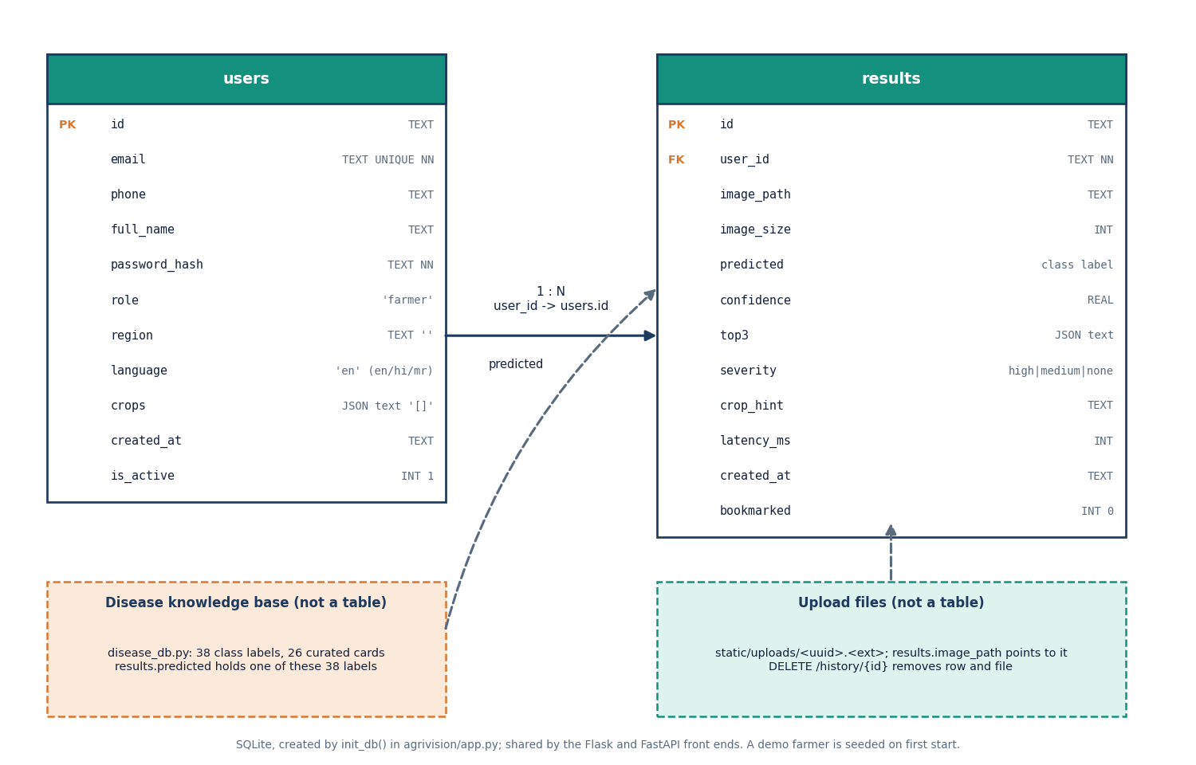
Figure 9: Entity-relationship diagram of the SQLite database (tables users and results).
The database has two tables created by init_db(). users holds the account (id, unique email, phone, name, password hash, role, region, language, a JSON text list of crops, creation time and an active flag). results holds one row per scan (id, user_id, image path and size, the predicted class label, confidence, a JSON text copy of the top three, severity, the crop hint, latency and time, and a bookmark flag). The relation is one user to many results. The disease knowledge base and the image files are drawn as dashed boxes because they are not tables: results.predicted stores one of the 38 class labels and results.image_path points to a file in static/uploads.

Flowchart of the core algorithm
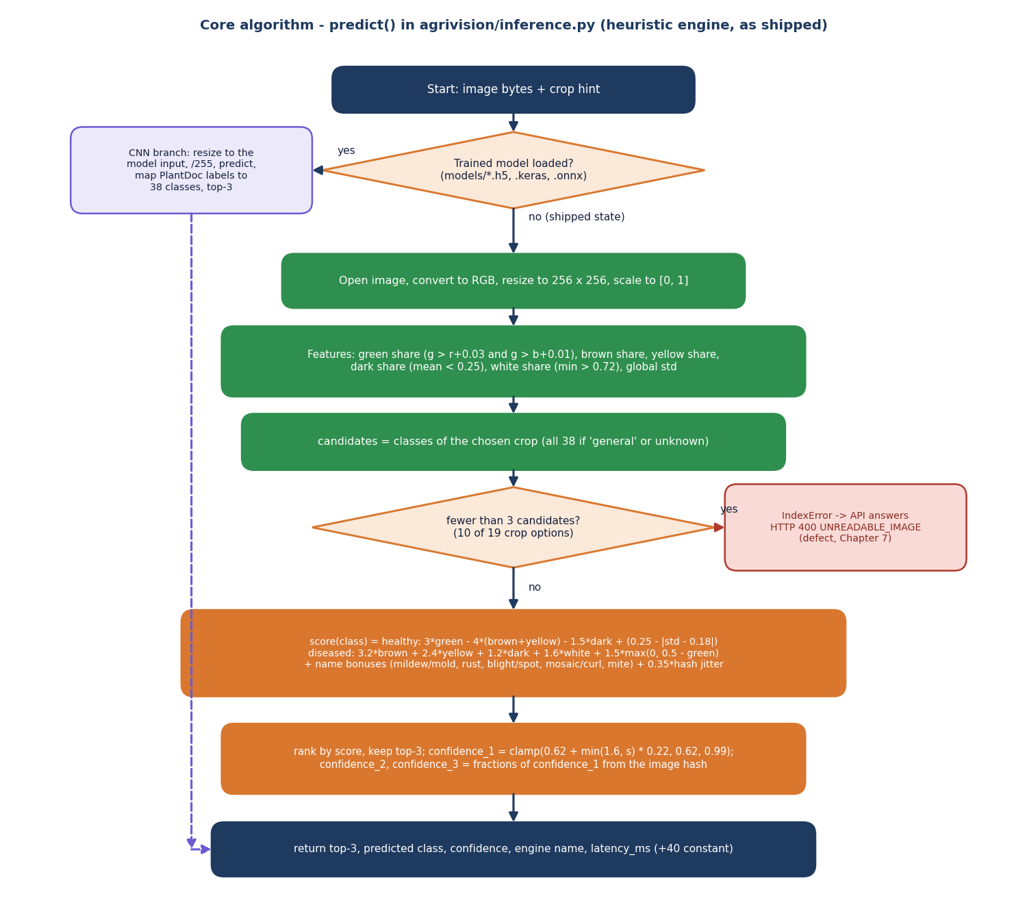
Figure 10: Flowchart of predict() in agrivision/inference.py (the shipped heuristic engine).
The flowchart follows predict(). If a Keras or ONNX model file is present the image is resized to the model input, scaled to [0, 1], passed through the network and the three largest outputs are mapped to the 38 classes. Otherwise, as shipped, the image is converted to RGB and resized to 256 x 256, six features are measured, the candidate classes of the chosen crop are selected, and a hand-written score is computed for each candidate. The three highest scores are kept, the first confidence is the clamped value 0.62 + 0.22 min(1.6, s), and the other two are fractions of it taken from the image hash. If fewer than three candidates exist the ranking raises an IndexError, which the API reports as HTTP 400 UNREADABLE_IMAGE.

Experiment protocol
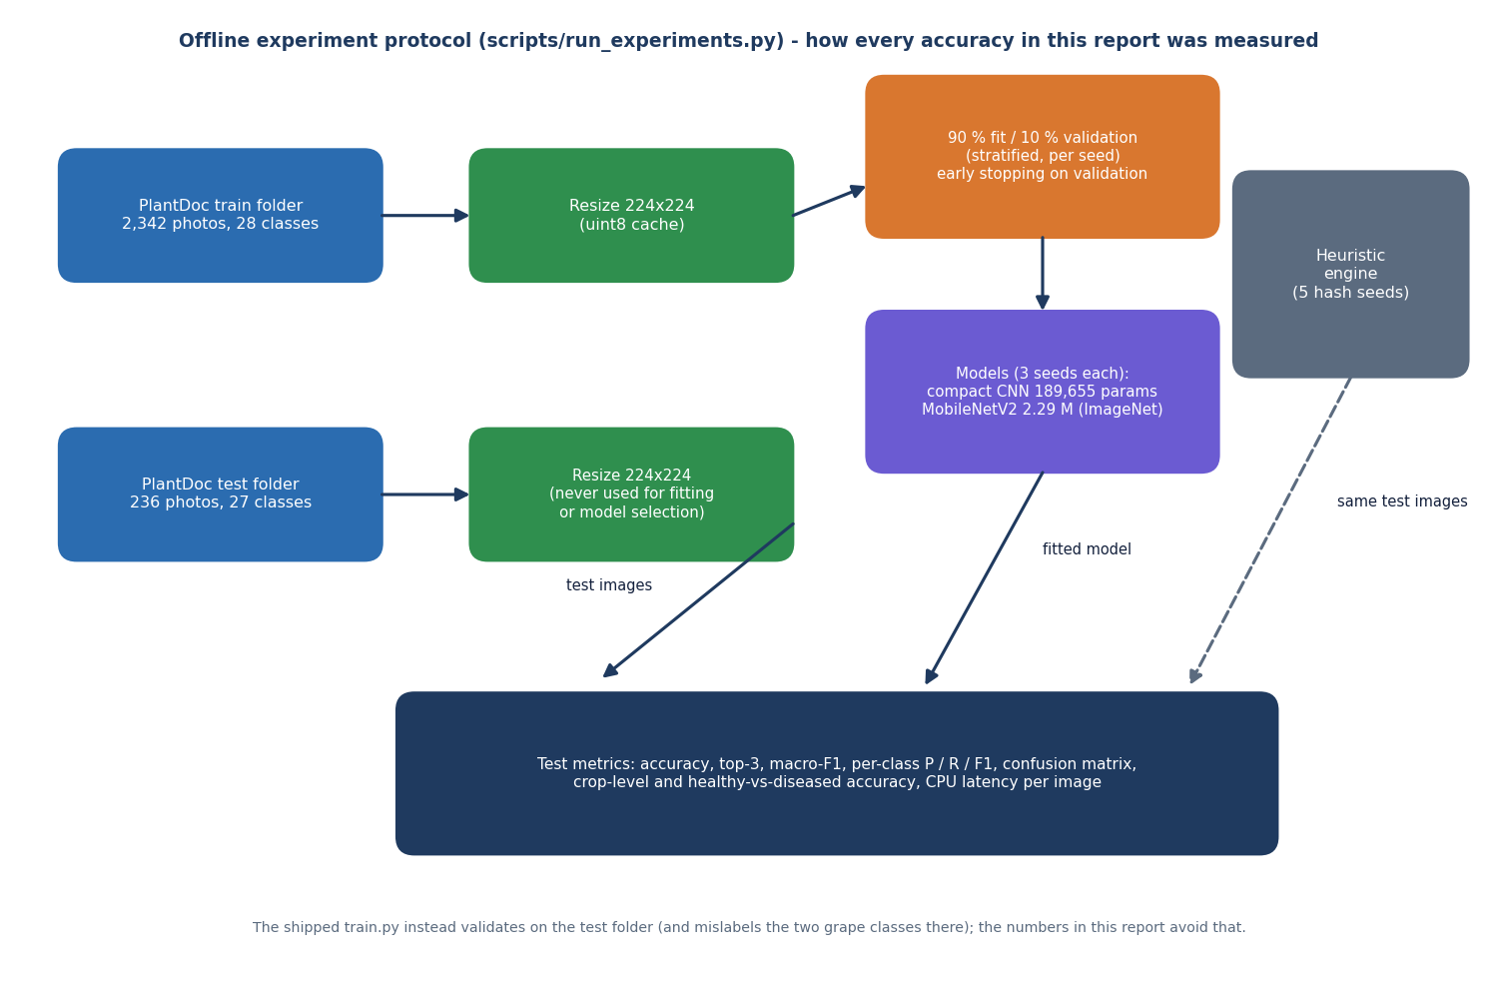
Figure 11: Offline experiment protocol used for every accuracy figure in this report.
Every accuracy in this report comes from scripts/run_experiments.py. The PlantDoc train folder (2,342 photographs, 28 classes) and test folder (236 photographs, 27 classes) are resized to 224 x 224 and cached. A stratified 10 % validation split is taken from the train folder for each seed and used only for early stopping; the compact CNN and MobileNetV2 are trained with seeds 42, 43 and 44. The test photographs are never used to fit or select a model. The shipped heuristic engine is evaluated on the same test photographs with five hash seeds. The shipped train.py instead validates on the test folder, which this protocol avoids.

Deployment view
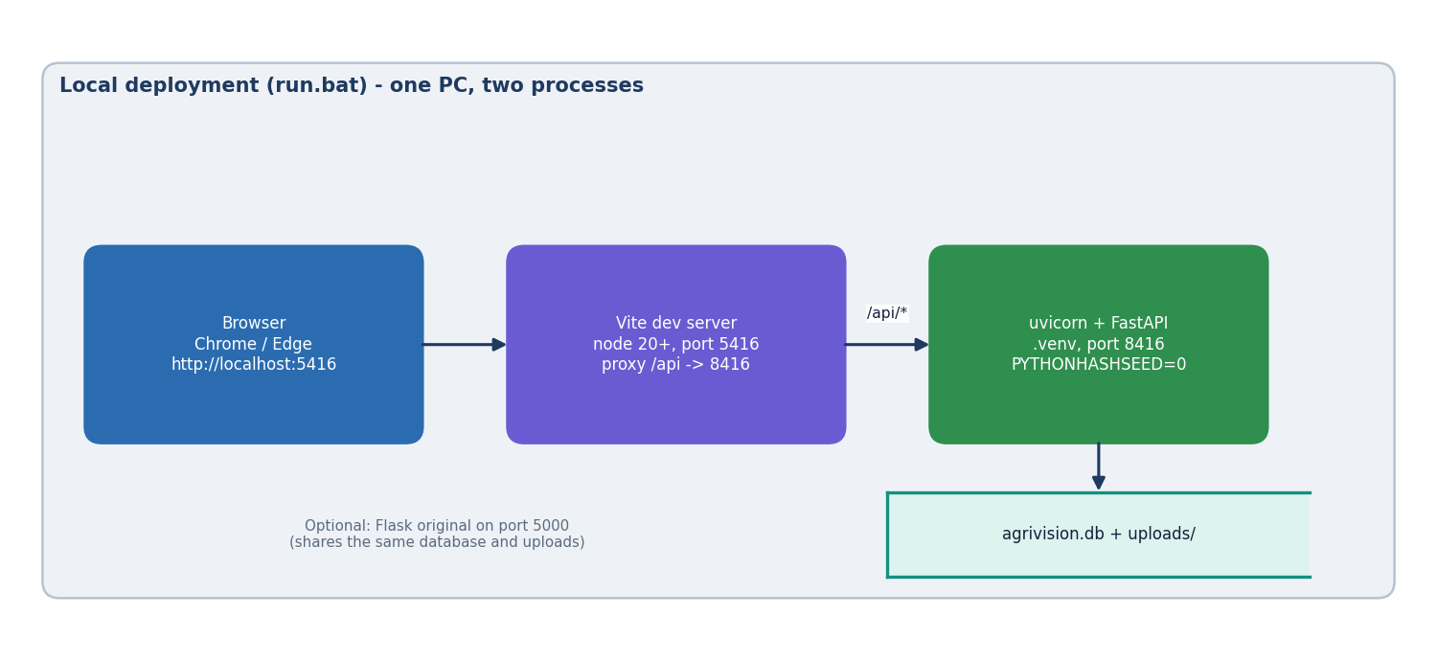
Figure 12: Local deployment of AgriVision started by run.bat.
run.bat creates a Python virtual environment, installs the backend requirements and the frontend packages, and starts two processes on one PC: uvicorn serving the FastAPI application on port 8416 with PYTHONHASHSEED=0 (so the heuristic's hash jitter is the same in every run) and the Vite server on port 5416 that proxies /api to it. The browser opens http://localhost:5416. The SQLite file and the upload folder are local to the machine. The original Flask application can be started on port 5000 and shares the same database and uploads. Nothing in this setup is suitable for several simultaneous users without a production web server and a different database.

